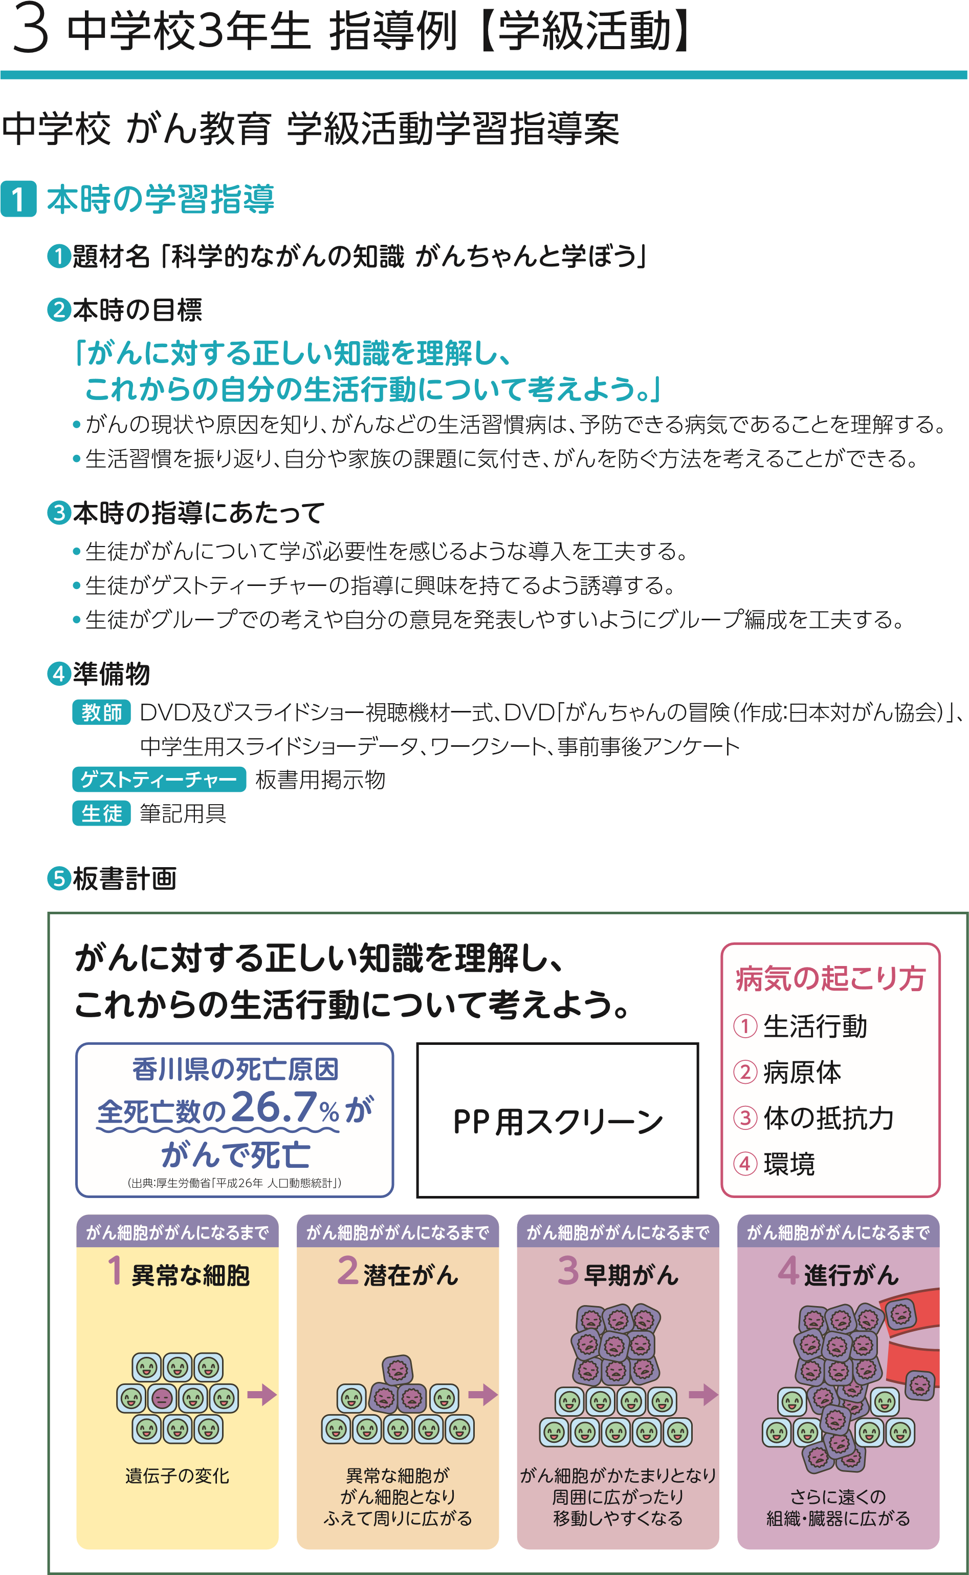

香川県の死亡原因

全死亡数の24.6%が

がんで死亡

（出典：厚生労働省「令和２年人口動態統計」）

28

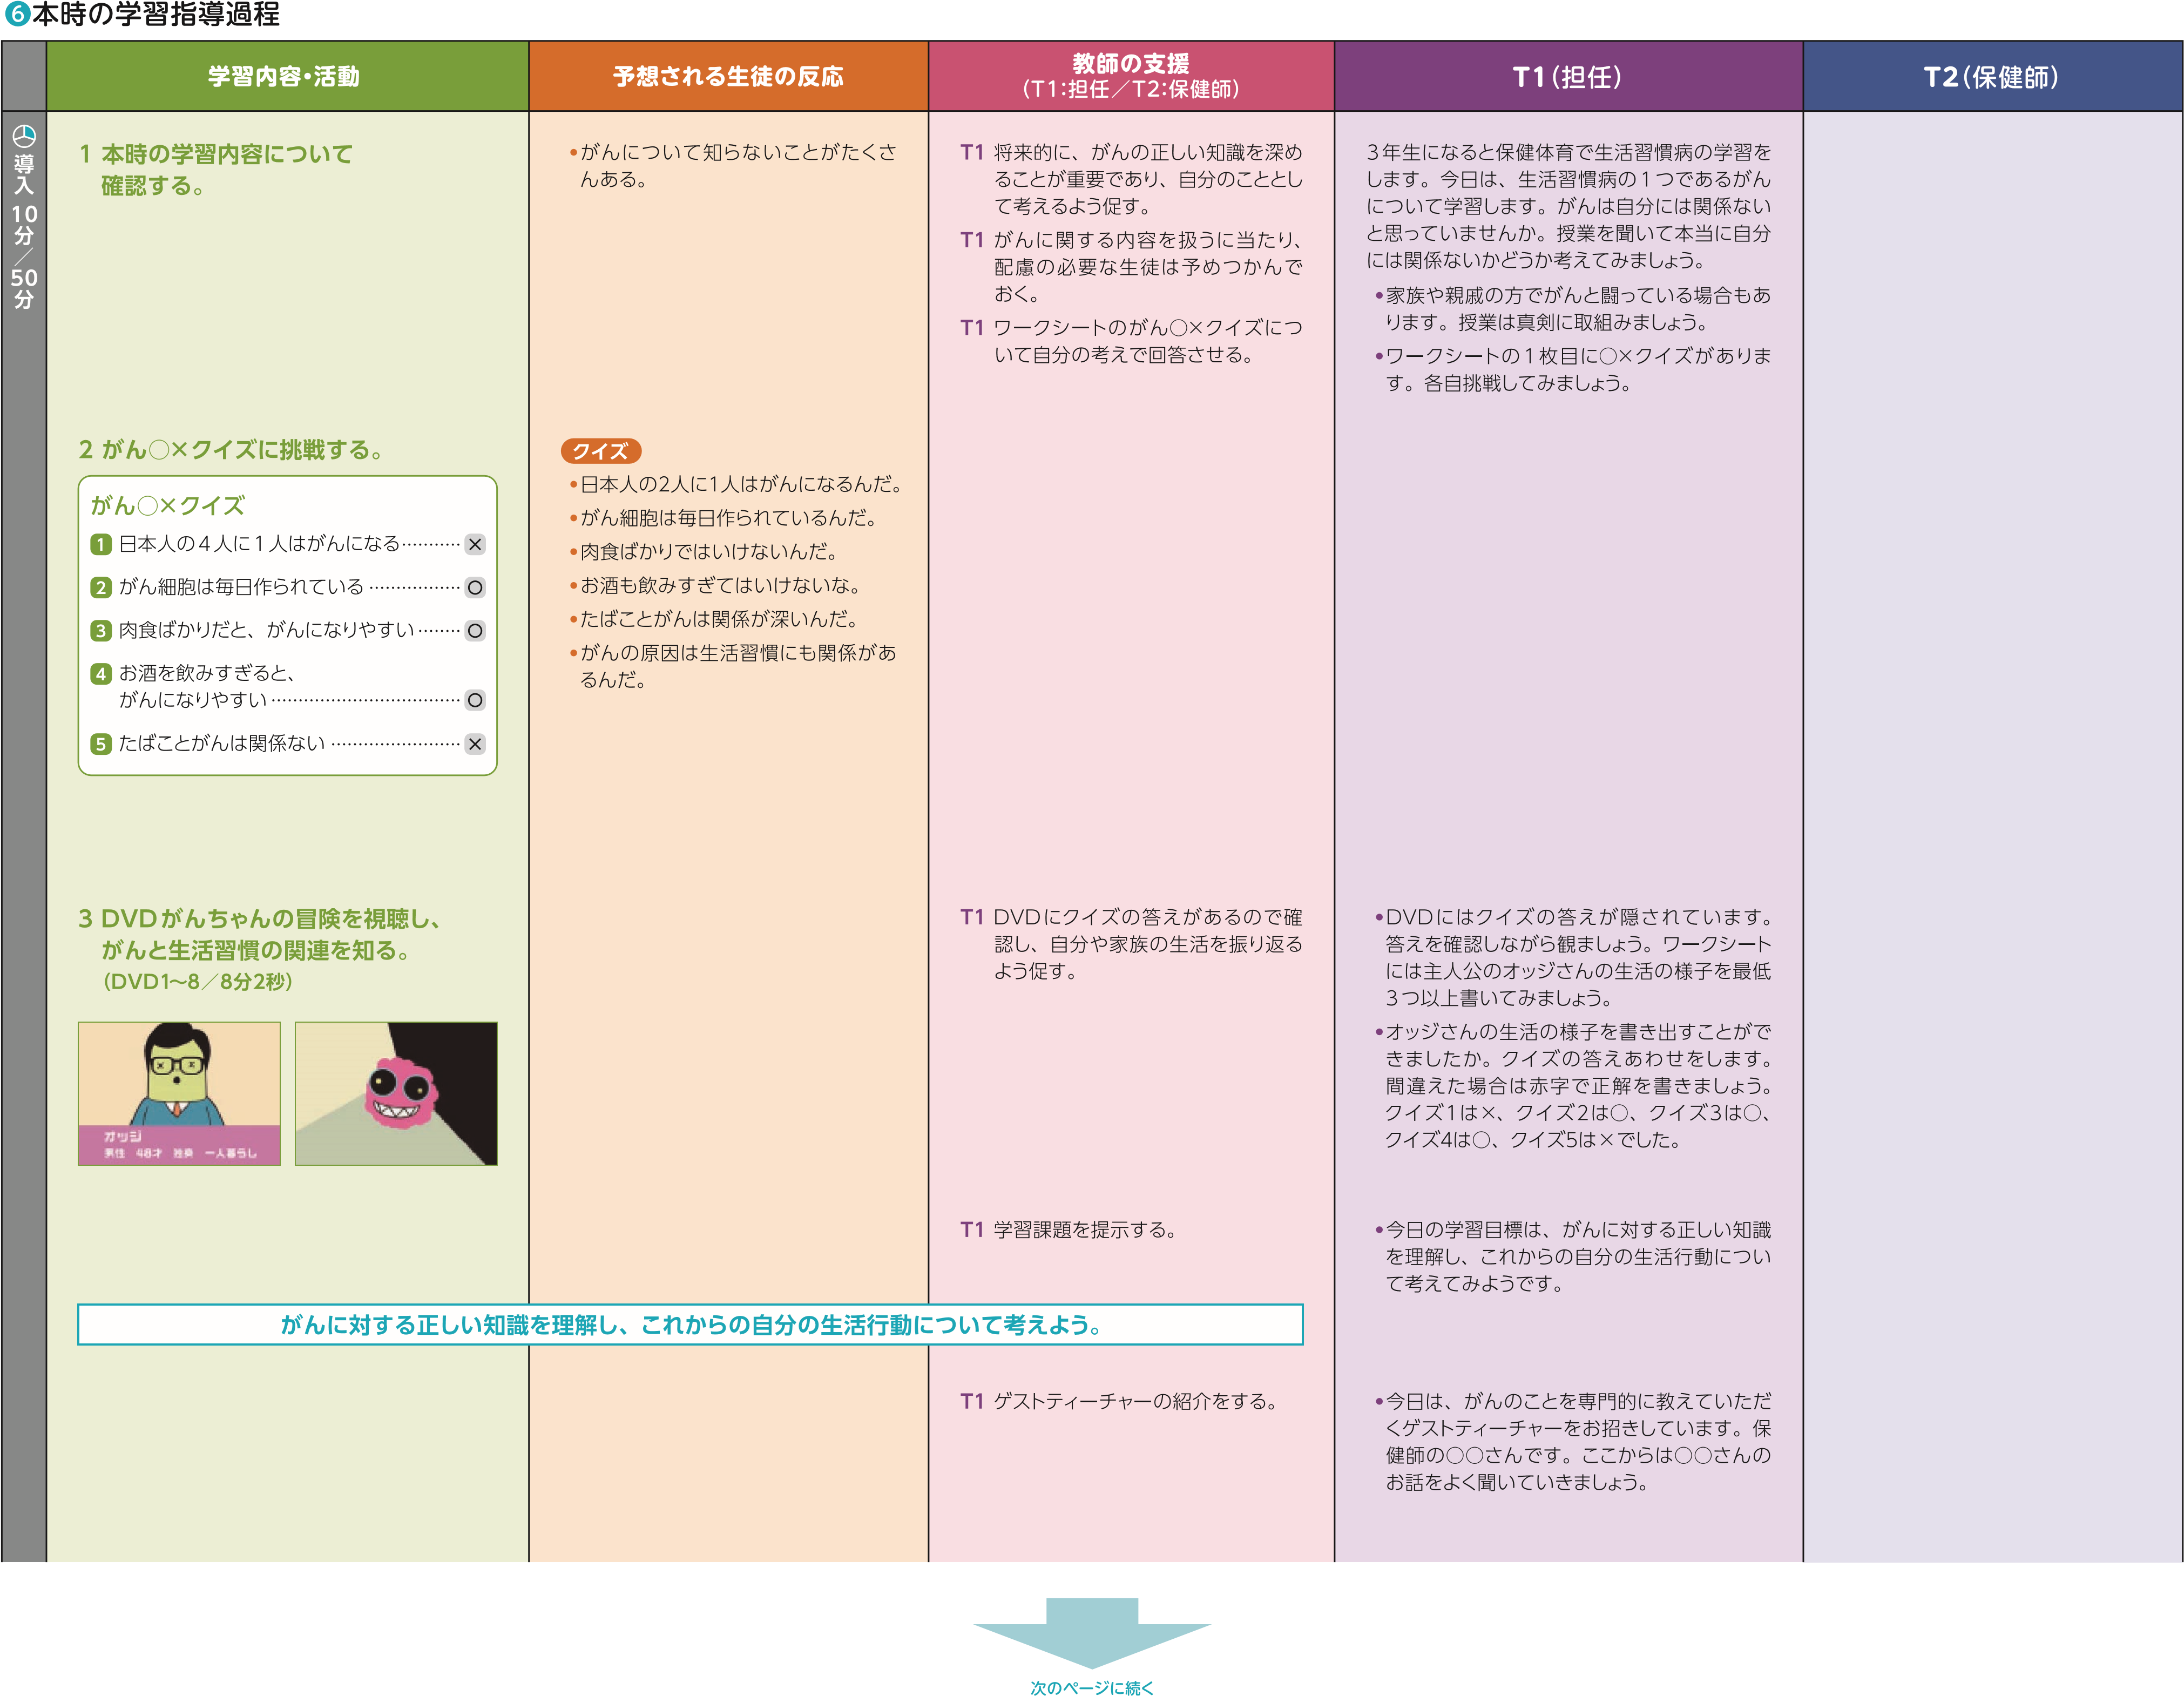

29

|  |  |  |  |  |  |
| --- | --- | --- | --- | --- | --- |
|  |  |  |  |  |  |
|  |  |  |  |  | ・**答えは、１位肺がん、２位大腸がん、３位は胃がん、４位膵臓がんです。前のスライドを参考に正解を　ワークシートに書きましょう。** |

30

|  |  |  |  |  |  |
| --- | --- | --- | --- | --- | --- |
|  |  |  |  |  |  |
|  |  |  |  |  |  |

|  |  |  |  |  |  |
| --- | --- | --- | --- | --- | --- |
|  |  |  |  |  |  |
|  |  |  |  |  |  |

|  |  |  |  |  |  |
| --- | --- | --- | --- | --- | --- |
|  |  |  |  |  |  |
|  |  |  |  |  |  |

|  |  |  |  |  |  |
| --- | --- | --- | --- | --- | --- |
|  |  |  |  |  |  |
|  |  |  |  |  |  |

